# Lab 3 Bar Moshe, Gabriel Lempart

1. Client’s IP : 192.168.2.12 .  
   Client’s TCP port number: 65361.
2. Gaia’s IP: 128.119.245.12 .  
   Gaia’s TCP porn number : 80.
3. The TCP opened 2 ports(65361, 65362) and that is the only change.
4. The client’s port will remain unchanged because the only port that will change is the TCP port instead of 80 it will be a port that support UDP protocol.
5. a. Seq num is 0   
   b. The syn segement can be seen to be set to 1.

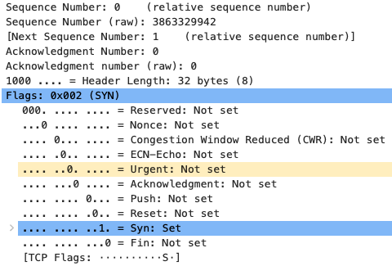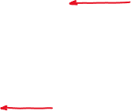

1. a,b. Both the seq num and acknowledgment num is one.  
   c. Gaia determined the value with adding to the seq num 1 to the last segment.  
   d. acknowledgment and syn set   
   Table

   Description automatically generated with medium confidence



1. a. The seq num is 1.  
   b. line number 43  
   c.  
   Table

   Description automatically generated with medium confidence

|  |  |  |  |
| --- | --- | --- | --- |
| Segment | SYN | SYN sent time | ACK time received |
| 1 | 1 | 18:23:33.064493 | 18:23:33.064675 |
| 2 | 707 | 18:23:33.064675 | 18:23:33.203978 |
| 3 | 2119 | 18:23:33.204079 | 18:23:33.206522 |
| 4 | 3531 | 18:23:33.206567 | 18:23:33.344763 |
| 5 | 6355 | 18:23:33.344838 | 18:23:33.350030 |
| 6 | 12003 | 18:23:33.350054 | 18:23:33.492256 |

1. Segment X length = (Segment X+1 SYN)- (Segment X SYN).  
   example : segment 3 length = (Segment 4 SYN)- (Segment 3 SYN)=3531-2119=1412 bytes.

|  |  |
| --- | --- |
| Segment | Length (bytes) |
| 1 | 706 |
| 2 | 1412 |
| 3 | 1412 |
| 4 | 2824 |
| 5 | 2824 |
| 6 | 2824 |

1. The minimum amount of available buffer space is :  
     
   The lack of receiver buffer space does not throttle.
2. There aren’t retransmitted segments. I looked for repeating segment .
3. The receiver typically acknowledges 2824 bytes in an ACK,   
   it’s happens when he data is doubled.
4. The file is 12003 bytes dive that by the total time 0.427763 seconds and average throughput is  28,059.9304 bytes per second
5. It present the RTT which is the delay time and how it’s increases over the time.  
   Chart, line chart

   Description automatically generated
6. It present the SYN number over time which is how much data has been transferred and received  
   in each time unit.  
     
   
7. The measured data is only using a fraction of the window size , $\frac{1}{3}$ to $\frac{1}{2}$.
8.   
     
     
     
   